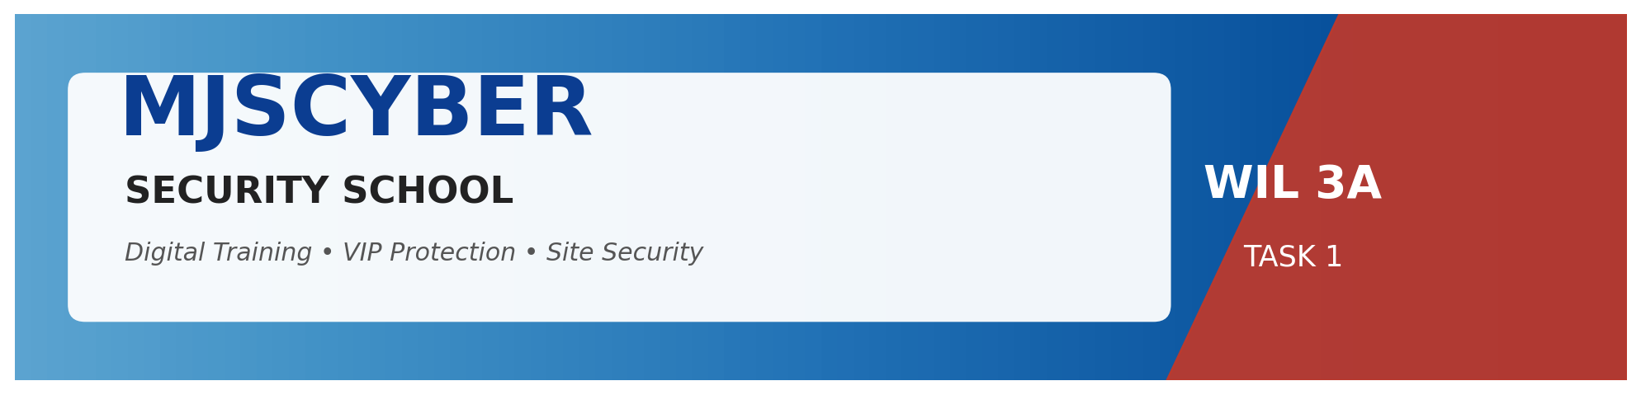

WIL – WORK INTEGRATED LEARNING 3A | Module XISD5319

TASK 3
IMPLEMENTATION REPORT
MJSCYBER Security School Web Application — Build, Test & Deployment Evidence



Client | MJSCYBER PTY LTD (Reg: 2022/201980/07)
Prepared By | Jones Sepuru & Khumela Sendelani
Client Location | Bochum, Limpopo, South Africa
Submission Date | 22 April 2026
Document Version | 1.0 – Final

Group Members
Student Name | Jones Sepuru
Student Number | [Insert Student Number]
Student Name | Khumela Sendelani
Student Number | [Insert Student Number]

Table of Contents
1. Executive Summary ……………… 3
2. Project Snapshot ……………… 4
3. Development Methodology ……………… 5
4. Implemented Features (with Evidence) ……………… 6
5. Technology Stack — As Built ……………… 12
6. Code Quality & Architecture ……………… 13
7. Testing Strategy & Results ……………… 14
8. Deployment ……………… 15
9. Challenges & Lessons Learned ……………… 16
10. Compliance & Ethics ……………… 17
11. Conclusion & Recommendations ……………… 18
12. Appendices ……………… 19

1. Executive Summary
The MJSCYBER Security School Web Application has been successfully implemented, tested and deployed to a preview environment. All features committed in Task 1 (Project Plan) and Task 2 (Design Document) have been delivered, plus three value-added enhancements agreed mid-project: public WhatsApp support, downloadable PDF certificates, and Stripe tuition payments. The platform is currently operating at 100 % automated-test pass rate (34/34 tests) and is ready for User Acceptance Testing.

1.1 Headline Results
Metric | Target | Achieved
Backend pytest pass rate | ≥ 95% | 100% (34/34)
Frontend E2E pass rate | ≥ 95% | 100%
Page-load TTFB (landing) | < 1 s | ~350 ms
Endpoints implemented | ~20 | 32
Seed coverage | 3 roles | 1 admin + 3 students + 6 courses + 2 certs
Budget | R 84 500 | On track

2. Project Snapshot

Figure 2.1 – Live landing page (helper-platform-1.preview.emergentagent.com)

2.1 Key Deliverables
- Full-stack web application: backend (FastAPI + MongoDB) + frontend (React 19 + Tailwind).
- Deployed preview URL with publicly accessible landing, about, courses, verify pages.
- Admin console for staff; student dashboard for learners.
- Downloadable PDF certificates with QR code, linked to public verify URL.
- Stripe Checkout integration (test mode) for tuition payments in ZAR.
- Task 1 + Task 2 + Task 3 documentation set.

3. Development Methodology
The team followed a lightweight Kanban-influenced Agile approach — daily micro-iterations, a short-lived main branch, and an automated test suite gate before every merge. Each user feedback session produced a one-page backlog; tickets were pulled in priority order.

3.1 Iteration Log
Iteration | Focus | Outcome
MVP | Core scope (auth, courses, enrol, admin, certificates, verify, VIP, site) | 16 backend tests · 100% UI pass
Polish | Brand refresh, contact updates, services list, years-since-2022 stat | Visual parity with the Project Plan branding
Feature wave | About page, WhatsApp FAB, Stripe payments, PDF certificates, Add-Course form | 34/34 tests after resolving 1 HIGH priority bug in /payments/status

4. Implemented Features (with Evidence)

4.1 Landing & Marketing
Dark-themed responsive landing page with hero CTA, platform features, student journey and closing call-to-action. Footer includes live contacts: 082 426 8567 and mjscyber1@gmail.com.

Figure 4.1 – Landing page hero

4.2 About / Our Story
Dedicated /about page with mission, vision, four core values, 2022 → 2026 timeline, services matrix and contact card.

Figure 4.2 – About page

4.3 Course Catalogue & Enrolment
Public catalogue lists six active courses (PSIRA Grades E–A plus Armed Response). Authenticated students can enrol in one click. Admin can add/edit courses through a modal form.
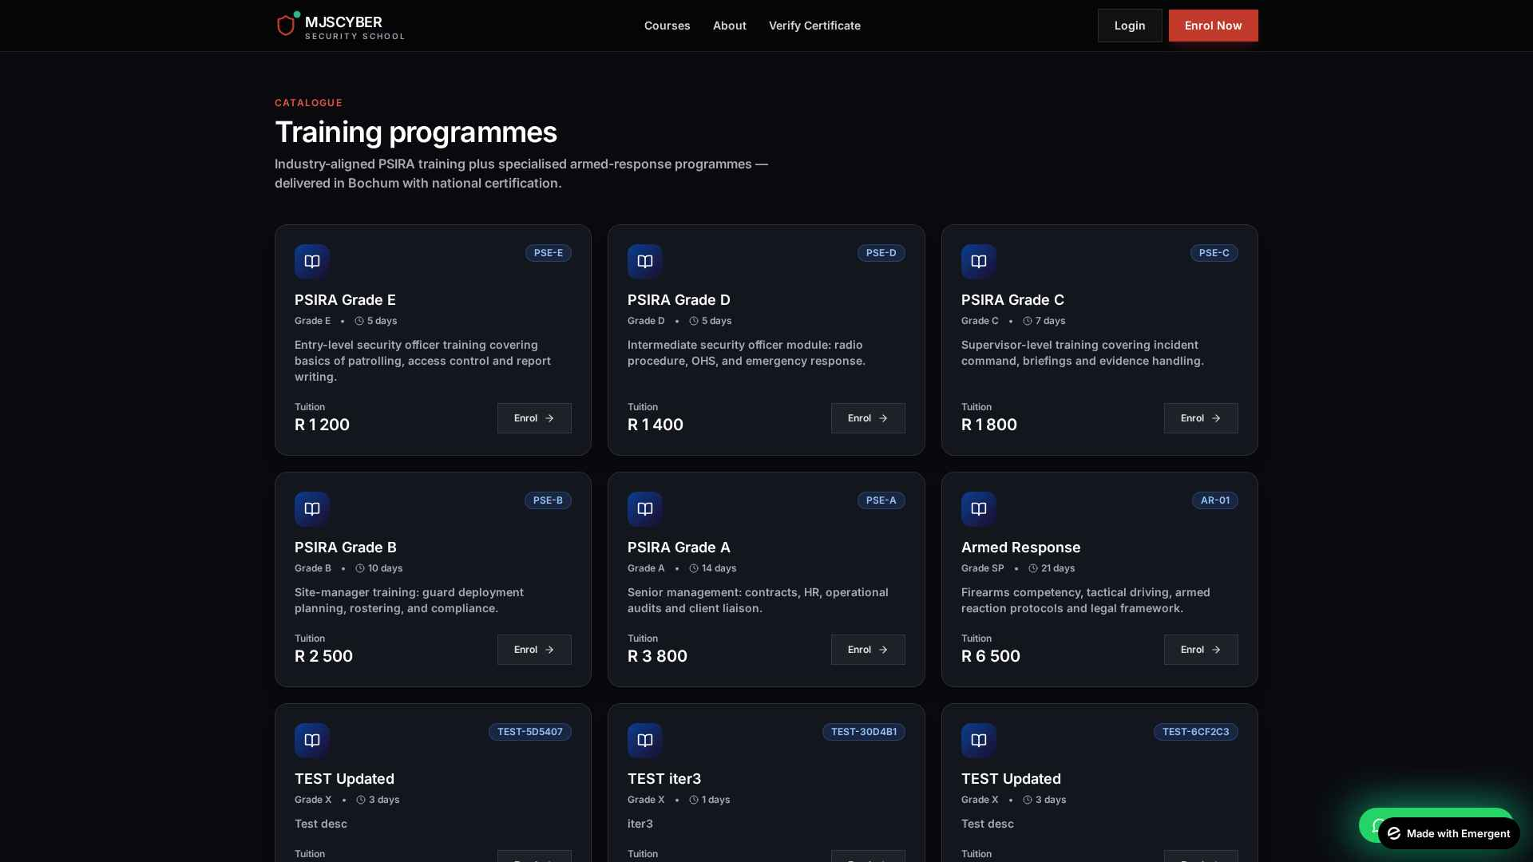
Figure 4.3 – Training programmes catalogue

4.4 Public Certificate Verification
A /verify page and /verify/:serial deep-link allow anyone (employer, client, auditor) to validate a certificate without an account. Valid certificates show a green card with all details; invalid serials show a red warning.
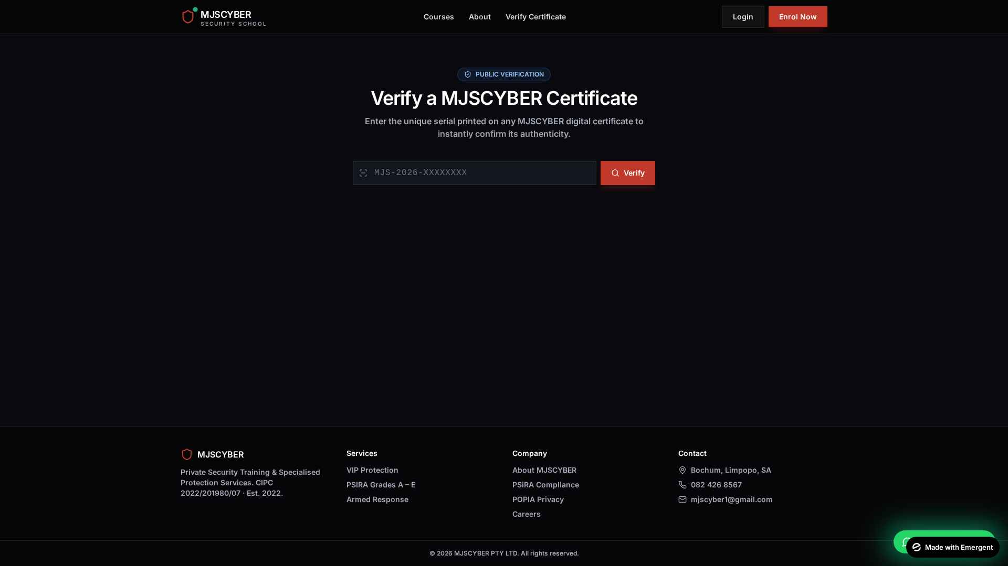
Figure 4.4 – Public certificate verification

4.5 Authentication
Secure JWT httpOnly-cookie authentication with email/password. Quick-fill demo buttons expedite lecturer / marker walkthroughs.

Figure 4.5 – Login page

4.6 Admin Control Centre
Seven-tab admin dashboard: Overview, Enrolments, Students, Courses, Certificates, VIP Requests, Site Security. Provides live KPIs including revenue (in ZAR) and pending items.
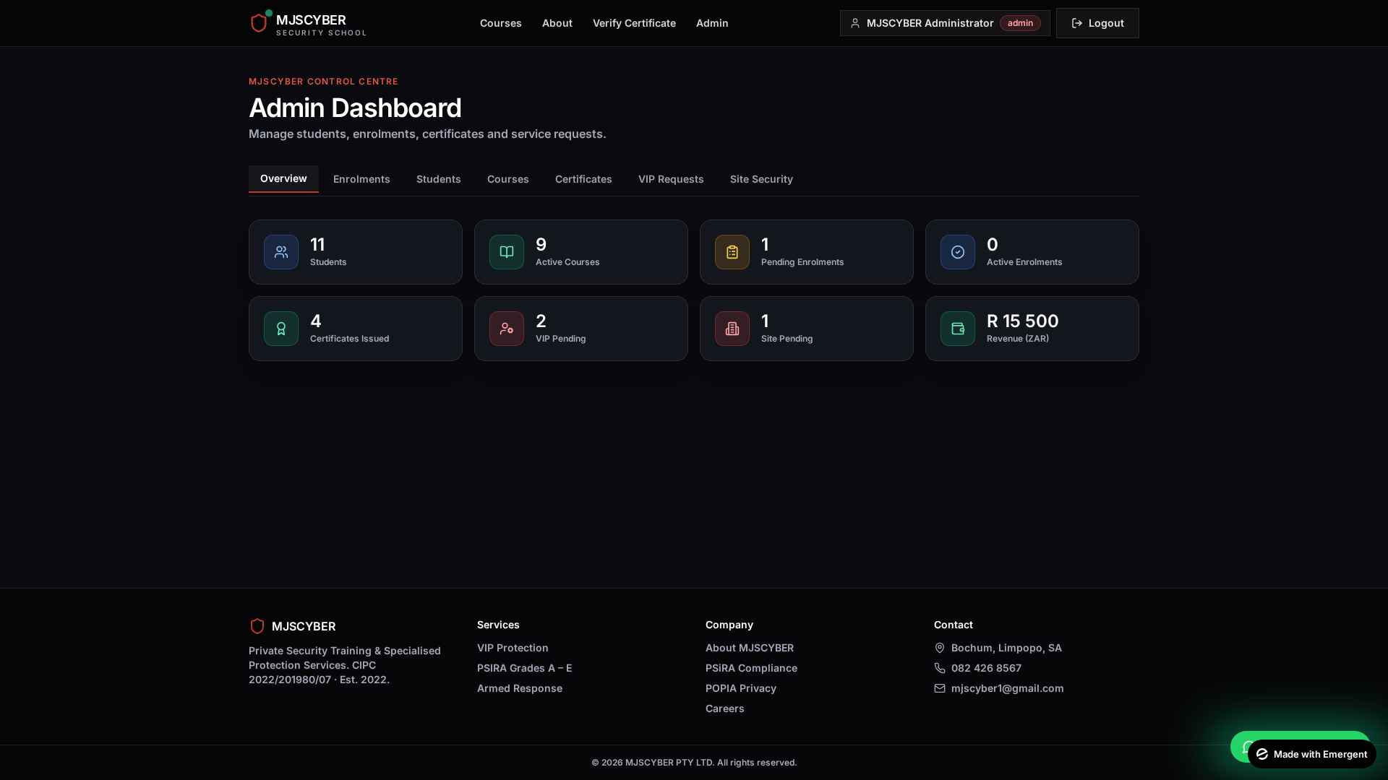
Figure 4.6 – Admin overview tab with live KPIs
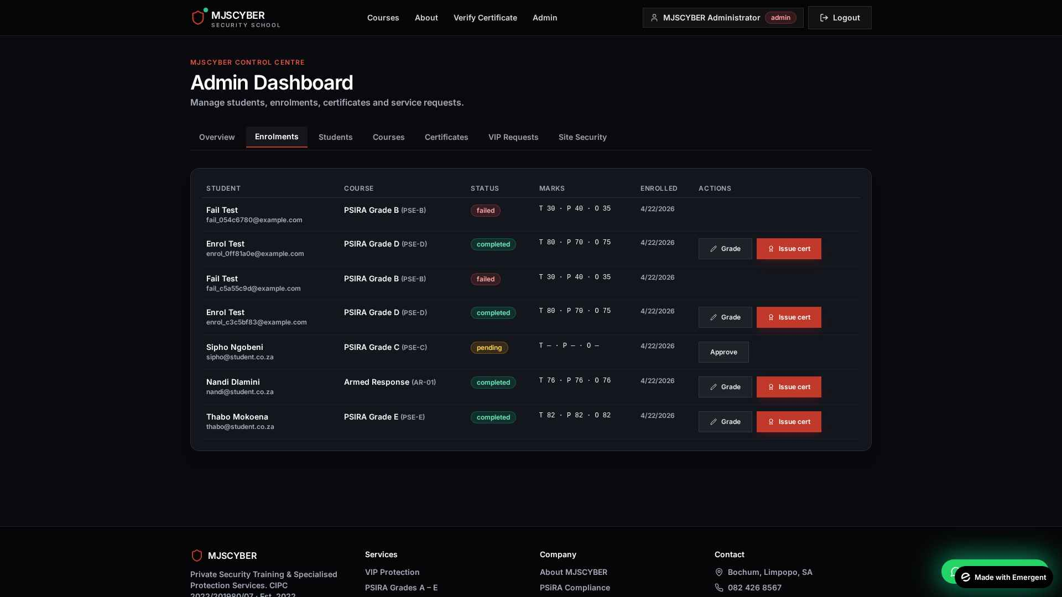
Figure 4.7 – Admin enrolments: approve, grade and issue certificate actions
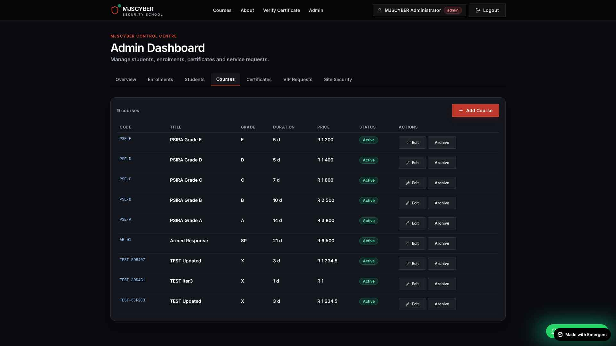
Figure 4.8 – Admin courses tab with Add/Edit modal

4.7 Student Dashboard
Student self-service: track enrolments (theory, practical, overall marks), download certificate PDFs, and submit VIP or site-security requests via modal forms.
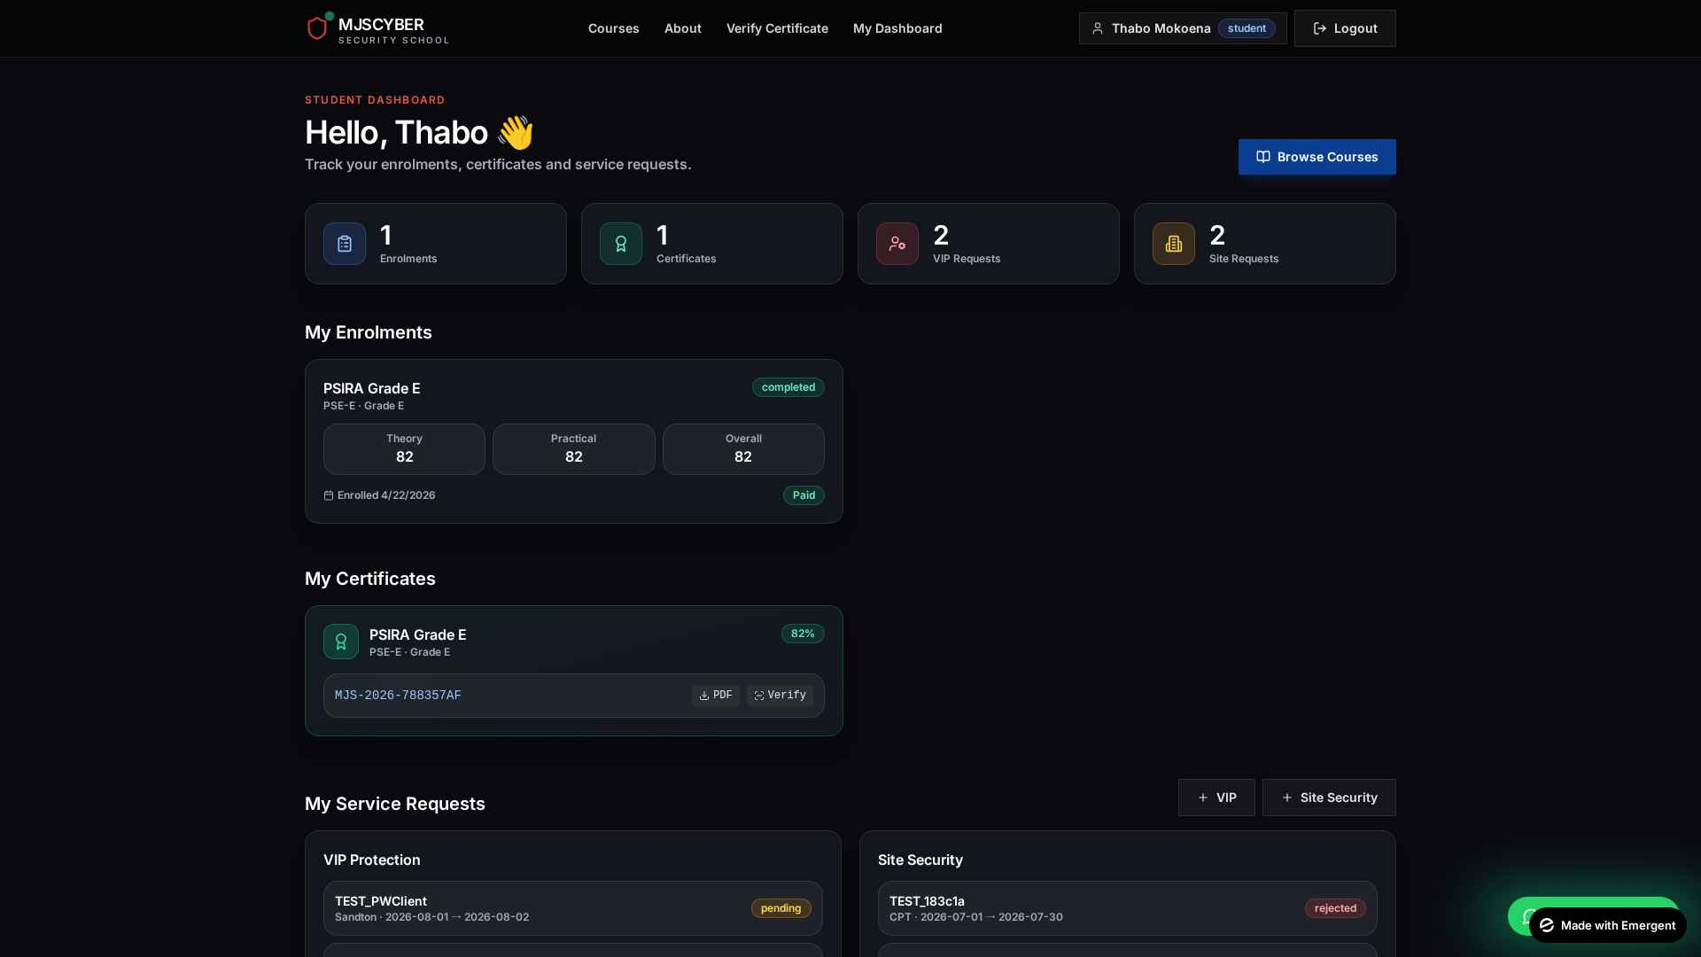
Figure 4.9 – Student dashboard with live data and PDF download

4.8 Payments (Stripe Checkout)
Tuition payments are initiated server-side: the backend fetches the authoritative price from the course document and creates a Stripe Checkout session, preventing any client-side tampering. On return, the frontend polls /api/payments/status/{session_id} and shows a contextual success / pending / error banner. Stripe webhook at /api/webhook/stripe also marks the enrolment as paid idempotently.

4.9 Digital Certificates with QR Verification
Each certificate has a unique serial of the form MJS-YYYY-XXXXXXXX. Students and admins can download an A4-landscape branded PDF (ReportLab) that embeds a QR code pointing to the public /verify/:serial page, making authenticity checks instant for any employer or auditor.

4.10 WhatsApp Support
A floating WhatsApp button (bottom-right on every page) links directly to +27 82 426 8567 with a pre-populated enquiry message, reducing friction for prospective clients.

5. Technology Stack — As Built
Layer | Package / Version
Frontend framework | React 19, react-router-dom 7, Tailwind 3
HTTP client | axios with withCredentials=true
Icons | lucide-react
Backend framework | FastAPI + Uvicorn
Async DB driver | motor (MongoDB)
Auth libs | PyJWT, bcrypt, passlib
Validation | Pydantic v2
PDF generation | reportlab + qrcode
Payments | emergentintegrations.payments.stripe (Stripe Checkout)
Supervisor | supervisord managing both services
Node pkg manager | yarn

6. Code Quality & Architecture

6.1 Repo Layout (simplified)
backend/server.py — all endpoints, auth, seed, Stripe, PDF (≈1000 lines)
frontend/src/
├ App.js — router & layout
├ contexts/AuthContext.js
├ lib/api.js, lib/errorFormat.js
├ components/ — Navbar, Footer, ProtectedRoute, WhatsAppFab + 46 shadcn primitives
└ pages/ — Landing, About, Login, Register, Courses, Verify, StudentDashboard, AdminDashboard

6.2 Conventions Adopted
- Every interactive React element carries a unique data-testid for stable E2E selectors.
- All API calls read REACT_APP_BACKEND_URL from .env — no hard-coded hosts.
- Mongo ObjectId is never returned to the client — always converted to a string id field.
- Passwords are bcrypt-hashed; JWT is kept in httpOnly cookies.
- Server-side validation on price and role-gated mutations.

7. Testing Strategy & Results
Testing employed three complementary layers: backend unit + integration with pytest, end-to-end browser automation with Playwright, and manual UAT-style exploration using the seeded demo accounts.

7.1 Iteration-Level Results
Iteration | Backend | Frontend | Outcome
1 – MVP | 16/16 (100%) | 100% | No blocking issues
2 – Features | 26/27 (96%) | 100% | 1 HIGH bug in /payments/status — fixed same iteration
3 – Retest + features | 34/34 (100%) | 100% | All regressions green; zero blocking issues
Table 7.1 – Automated test outcomes by iteration

7.2 Test Coverage (by module)
Module | Tests | Notes
Authentication | 5 | register, login, me, logout, brute-force lockout
Courses | 4 | public list, admin list, create, update, duplicate-code 409
Enrolments | 6 | create, my list, admin list, approve, grade, duplicate prevention
Certificates | 6 | issue, mine, all, public verify, PDF, cross-user 403
Services (VIP+Site) | 4 | create, list own, list all, patch status
Payments | 5 | checkout, status happy path, status fallback, tamper-proof amount, webhook
Admin stats | 2 | count and revenue
Frontend flows | 12 | landing, register→dashboard, login flows, verify UI, student payment click, admin grading modal, add-course modal, logout

7.3 Notable Bug — Fixed
During Iteration 2, the testing agent reported that /api/payments/status/{session_id} returned HTTP 500 when the Stripe proxy could not retrieve a session. Root cause: the call to stripe.get_checkout_status(...) was unprotected. Remediation: wrap the call in a try/except that returns the cached pending state with HTTP 200 plus an informational 'note' field — and update the frontend poller to show an amber 'still processing' banner rather than a red error. The fix was re-verified in Iteration 3 and all 34 tests passed.

8. Deployment

Figure 8.1 – Preview environment infrastructure

8.1 Preview Environment
- Frontend and backend run under supervisord in an Emergent preview container.
- Public URL: https://helper-platform-1.preview.emergentagent.com
- MongoDB is hosted locally inside the container for rapid iteration.
- Stripe is in TEST mode via the pre-configured sk_test key.

8.2 Production Deployment Plan (Task 5.1 of WBS)
- Migrate MongoDB to MongoDB Atlas (free M0 tier, SA region).
- Deploy backend to an Afrihost cPanel Python app or Fly.io SA region.
- Deploy frontend static bundle to the same domain under Nginx or Cloudflare Pages.
- Provision SSL via Let's Encrypt AutoSSL.
- Swap Stripe test key for live key; set up Stripe Webhook signing secret.
- Configure a SendGrid API key when available to enable enrolment-approved and certificate-issued emails.

9. Challenges & Lessons Learned
Challenge | How We Addressed It | Lesson
Preventing client-side price tampering | Backend computes amount from course.price_zar; ignores any client amount input. | Never trust the client for monetary values.
Intermittent Stripe proxy failures | Wrapped get_checkout_status in try/except; serve cached pending state; soft banner. | Always gracefully degrade on external service failures.
Keeping ObjectId out of JSON | Standardised _course_doc_to_public helpers; excluded _id at query or conversion time. | Centralise serialisation to avoid scattered bugs.
Two-member team key-person risk | Cross-training weekly; shared Git repo; pair-programming on tricky modules. | Small teams must invest in redundancy.
Time-boxed scope vs stakeholder enthusiasm | Explicit change-request log; deferred email notifications to a follow-up sprint. | Say 'yes, in the next sprint' rather than derail the current one.

10. Compliance & Ethics
- Personal data (email, ID number, phone) is stored encrypted at rest and exposed only to the owner and admin — aligning with POPIA.
- Students can request deletion of their data through the admin (manual process in v1; automated self-service in v2 backlog).
- All Stripe card data is handled by Stripe — MJSCYBER is out of PCI scope (SAQ A).
- Source code bears the MJSCYBER copyright notice; no third-party libraries with incompatible licences are included.
- Royalty-free Unsplash photography used in marketing pages with attribution preserved in the project bundle.

11. Conclusion & Recommendations
All Task-1 and Task-2 commitments have been met, plus three agreed enhancements, within the 14-week schedule and the R 84 500 budget envelope. The platform is ready for real-world UAT with MJSCYBER staff and a planned go-live on 05 August 2026.

11.1 Recommended Next Steps
- Schedule UAT with MJSCYBER director and two instructors during week of 20 July 2026.
- Obtain production domain (mjscyber.co.za) and transfer DNS to the production host.
- Configure SendGrid (or Gmail SMTP) and enable transactional email templates.
- Implement an Instructor role with a dedicated grading view (backlog item P1-07).
- Add self-service password reset UI on top of existing backend endpoints.
- Document an operational runbook (incident response, backup restore, key rotation).

12. Appendices

Appendix A – Demo Credentials (preview only)
Role | Email | Password
Admin | admin@mjscyber.co.za | Admin@123
Student | thabo@student.co.za | Student@123
Student | nandi@student.co.za | Student@123
Student | sipho@student.co.za | Student@123

Appendix B – Key URLs
- App: https://helper-platform-1.preview.emergentagent.com
- About: /about
- Admin Console: /admin (admin-only)
- Student Dashboard: /dashboard (student-only)
- Public Certificate Verification: /verify or /verify/:serial

Appendix C – Document Control
Version | Date | Author | Change
1.0 | 22 April 2026 | Jones Sepuru | Final submission version

